ET-3206 DD LABORATORY

JOURNAL
EXPERIMENT - 2

Logic Gates: Two Input NOR-Gate

Group No.: - ET-B3 G9

Group Members

1. Raghavi Narayanan(12311308)

Objectives:

To design and simulate a two-input CMOS NOR gate using Cadence Virtuoso
(a) To design an CMOS NOR Gate with a symmetric VTC.
(b) To calculate the propagation delay of the NOR gate.
EDA Tool used:

Cadence Virtuoso – Schematic, Symbol creation, Testbench design and Simulation

1. CMOS NOR Gate – Schematic Description
The two-input NOR gate is implemented using CMOS technology. The circuit consists of:
- Two PMOS transistors connected in series between VDD and the output node acting as the PUN (Pull-Up Network).
- Two NMOS transistors connected in parallel between the output node and GND acting as the PDN (Pull-Down Network).
- Inputs: A and B
- Output: Y
If either A or B is HIGH, at least one NMOS is ON and at least one PMOS in the series path is OFF then the output is pulled LOW.

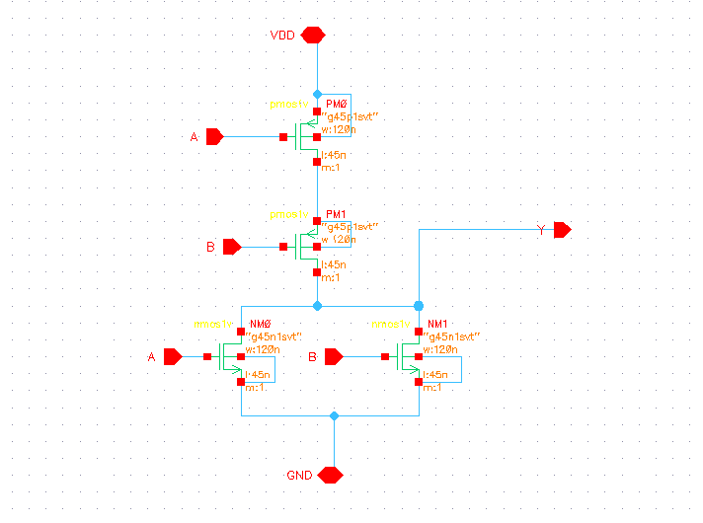

2. Symbol Description:

A symbol is created from the schematic for reuse in higher-level designs.
Steps in Cadence Virtuoso:
- Open NOR schematic
- Click: Create → Cellview → From Cellview
- Select:
  - From view: schematic
  - To view: symbol
- Place pins:
  - A, B → left side
  - Y → right side
  - VDD → top
  - GND → bottom

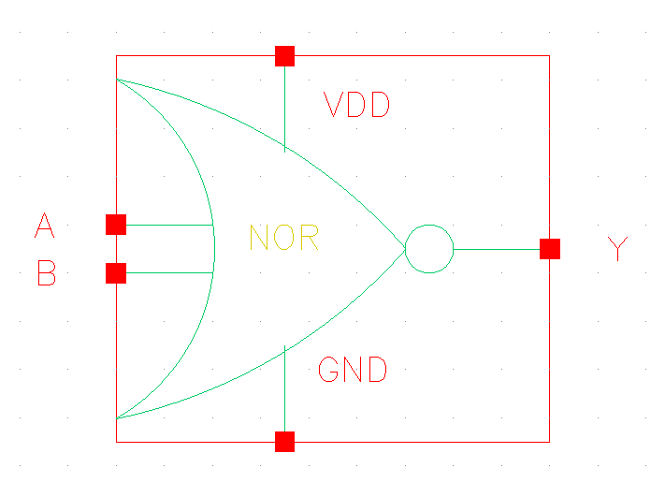
Simulation in Cadence Virtuoso

A. DC Sweep Analysis
Purpose:
To observe how the output changes as input voltage is swept from 0V to VDD.

Steps to perform DC Sweep:
- Open ADE
- Click: Analysis → Choose
- Select dc
- Choose:
  - Sweep variable: Component Parameter
  - Select voltage source (VA or VB)
  - Start: 0
  - Stop: 1.0
  - Step: 0.1
- Click OK
- Select outputs to plot:
  - v(A)
  - v(Y)
- Run simulation

Observation:

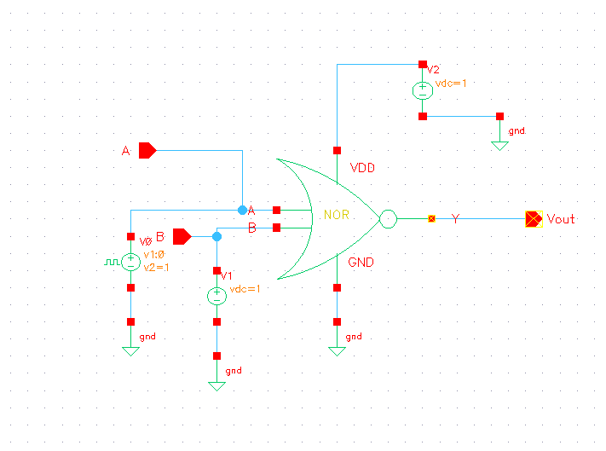

Testbench when B is constant (1 volts) and A is varying from 0 -1 Volts

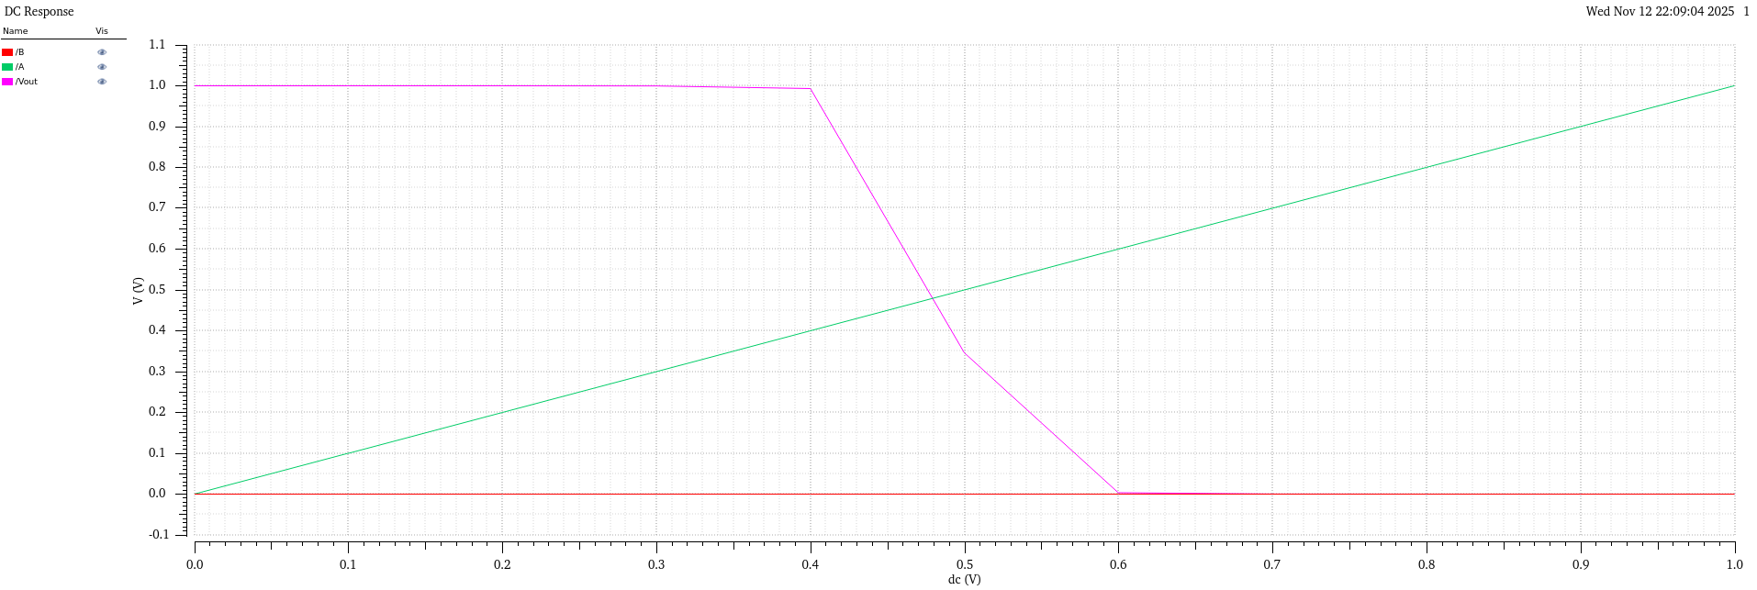
Simulation when B is constant (switching threshold : 478.68 mV)

B. Transient Analysis

Purpose:
To observe time-domain behaviour of NOR gate for changing inputs.

Steps to perform Transient Simulation:
- Open ADE
- Click: Analysis → Choose
- Select tran
- Set:
  - Stop time: 100n
- Click OK
- Select signals:
  - v(A), v(B), v(Y)
- Click: Simulation → Run

Observation:
Testbench for transient analysis

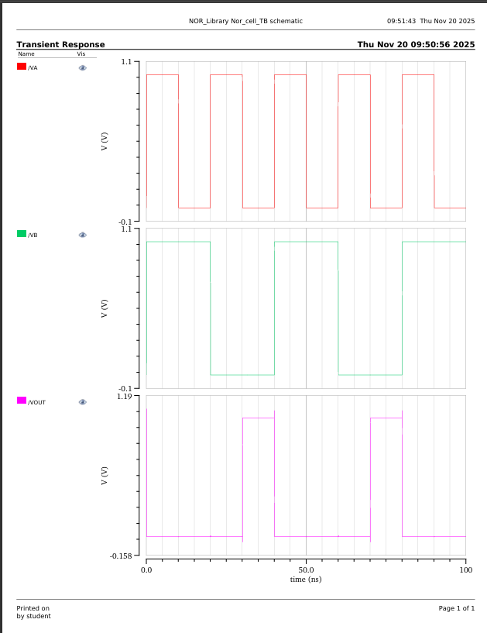
Transient waveform confirming the operation of NOR gate

Conclusion:

In this experiment, a two-input CMOS NOR gate was designed and simulated in Cadence Virtuoso. DC sweep and transient analyses were carried out to study its static and dynamic behaviour. The VTC plots helped us observe the switching threshold of the gate and verify that the device sizing gives a threshold close to VDD/2. The transient waveforms confirmed the expected NOR truth table – the output is HIGH only when both inputs are LOW.
Using the delay calculator, the propagation delays were obtained and the average delay was computed. Overall, this experiment helped us understand the CMOS implementation of a NOR gate, the role of pull-up and pull-down networks, and how sizing and loading affect switching threshold and propagation delay.

